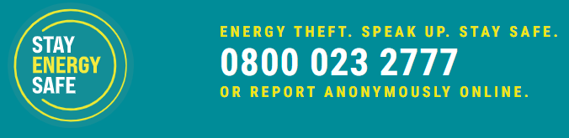

Meter Tampering: A Hidden Danger to tenants, properties and the community
Meter tampering poses significant risks to property, tenants and communities. Stay Energy Safe offers a solution that allows people to anonymously report their concerns.
Tampering with meters can result in explosions, fires, electric shocks, burns, gas leaks and even injury and death, with real-life cases illustrating the consequences here.
Financial challenges can drive individuals to tamper with their meter without considering the impact it has on the neighbours.
Since the cost of living crisis, Stay Energy Safe, which the charity Crimestoppers runs, receives around 1,000 reports each month. It is estimated that energy theft occurs in approximately 1 in 150 homes every year, costing UK consumers £1.4 billion yearly with each consumer estimated to pay an extra £50 each year on their energy bills. Find out more about energy theft here.
You can find out how to recognise signs of energy theft here. These often include irregular wiring, sparking, burn marks, or gas smells.
Stay Energy Safe guarantees anonymity when reporting via their online form or when you call 0800 023 2777.
Reporting helps protect properties and lives. It's vital to stay vigilant and speak up to safeguard communities.

